A
Project Report on
Book Store Management System
Submitted to
Savitribai Phule Pune University
In the partial fulfillment of the requirement of the award of the degree of
Bachelor of Computer Application – TYBBA(CA) Sem VI
Academic Year 2017-18
By
Vishal Rai
Under the guidance of
Prof. Amit Tale
Through

Alandi (D) - Pune 412105

CERTIFICATE

Department of Computer Application

This is to certify that Mr.Vishal Rai, Exam Seat No ----------------. has successfully completed his project work entitled Book Store Management System in the partial fulfillment of the requirement of the degree of Bachelor Of Computer Application for the Academic Year 2017-18

Prof. Amit Tale Mrs. Akshada Kulkarni
Project Guide Head Of Department

Internal Examiner External Examiner

Acknowledgement

The words are not enough to express my thanks to Dr. B. B. Waphare, Principal, MIT Arts Commerce and Science College Alandi (D) for providing me with the opportunity to avail the excellent facilities and infrastructure of the institute.
It is my proud privilege to express my profound gratitude to Prof. Akshada Kulkarni, HOD, Computer Application Department, for her astute guidance, constant encouragement and sincere support throughout my academic course.
I thanks to my honest gratitude to Prof. Amit Tale for her inspiration, constructive suggestions and affectionate guidance in my project work completion.
Last but not the least, I express my sincere thanks to all my dear friends and family members for their constant motivation, moral support and invariable direction throughout my life.

DECLARATION

I, Vishal Rai hereby declare that this project work entitled Book Store Management System submitted at MIT, Arts Commerce and Science College, Alandi(D), (Affiliated to Savitribai Phule Pune University) is a record of original work done by me under the supervision and guidance of Prof. Amit Tale, Department of Computer Application.

Signature:
Name of Student: Vishal Rai.
Exam Seat No.:
Place: Alandi(D), Pune.

Date:

Index
sr.no | Contents | Page No
1 | Introduction
 | 1.1 Introduction of System
 | 1.2 Scope of System
 | 1.3 Proposed System
2 | System Analysis
 | 2.1Fact findings Techniques
 | 2.2Feasibility Study
 | 2.3 H/w & S/w Requirement
3 | System Design
 | 3.1 Entity Relationship Diagram
 | 3.2 Context Level Diagram
 | 3.3 Data Flow Diagram
 | 3.4 Data Dictionary
4 | From Design
5 | Report
6 | Advantages & Disadvantages
7 | Future Enhancement
8 | Bibliography

INRODUCTION:
Now a days, there are many company want to develop a software system for Book store Billing System. Because this is, they want to expand scope of their business activities, increase turnover and reduce the cost in time and labor.
Modern Book Store is a General Book Store, which buys and sells the Books as per the requirement of the customer. It has so many dealer ships from which the Books are purchased and also some of the Books it gets directly from the company and some of them from the wholesale retail shops.
For the past few months they are facing difficulties in the current system for tracking down the details of the available and that of the sold due to the increased consumption of the Books.The system solve their difficulties in maintaining the records of the sold ones and that of the available and also to track down the details of the Payments done to the distributors, received from the customers, etc… and also to track down the information of the quantity of the stock available and that of the purchasable.

Scope:
Registration of new user and authentication of existing user .A GUI containing text boxes, buttons, drop-down list boxes and labels which will provide a user-friendly interface to the user to work with the application .To allow add a new books, search all information. Edit or change, remove a Books details .To allow add a new customer, distributor, search for information has relationship .To allow add a new order, search for information, update order status Generation of reports has relationship

Proposed System:
Create a database for the Books Store Billing System. Add tables to store information about different products, supplier, customers … The manager can to manage and also to track down the details of the Payments done to the supplier, received from the customers, etc… and also to track down the information of the quantity of the stock available and that of the purchasable.

2. Analysis

Fact Finding Technique

Interview
  - Interviews were taken to gather information about the existing system and analysis was done
  - To observe the subject. The user & books were asked many questions about the existing manual system.
- How various customer details are maintained?
- How various doctors details are maintained?
- How to Book process is done?
- How customers Bill is generated?

Record Review:-
    - Record review may be performed in the beginning of the study to collect initial information or at end of study to compare actual operations. Information related with the system may be present in the form of records like books, magazines, journals, manuals etc. This kind of record review provides very valuable information to the analysis

Document Search:-

    - In order to design proper output Reports and input screens document searching is proved to be an important technique. we searching following document for this.

- Customer registers
- Supplier detail register
- Book Detail register

Feasibility Study
An important outcome of the system investigation is that it is found to be feasible.
#Technical
#Operational
#Economical

Technical Feasibility
The technical issues usually raised during the feasibility stage of investigation of center around the necessary technology existence, technical capacity of equipment to hold the data require Use the new system, and the technical guaranties of the accuracy, readability, ease of access etc.
The company is equipment with latest of hardware and software including MS-ACCESS 2013 and MS-VISUAL Studio. So the system is technical feasible.

Operational Feasible
The proposed system is a GUI (Graphical User Interface) application and also user friendly. Buttons are created for various operations. Alerts are prepared for the proper use of the system. There was a need for the development and enhancement of the existing system. Due to the enhancement of the existing manual system most of the difficulties were solved.

Economic Feasibility

This feasibility is mainly concerned with cost benefit analysis of the proposed system. Financial benefits must equal or exceed the cost. Since the hardware and software support is facilities that are require by the proposed system.

Software Requirement specification

Software requirement:

Operating system:-

Windows all OS

Software:-
Front End: - Visual Studio 2010
Back End: - Microsoft Access 2013

Hardware requirement:-

Minimum:

600 MHz and above processor speed.

256 MB Ram.

Only Color Monitor

2 GB and above free space

Printer

3. System Design

ERD
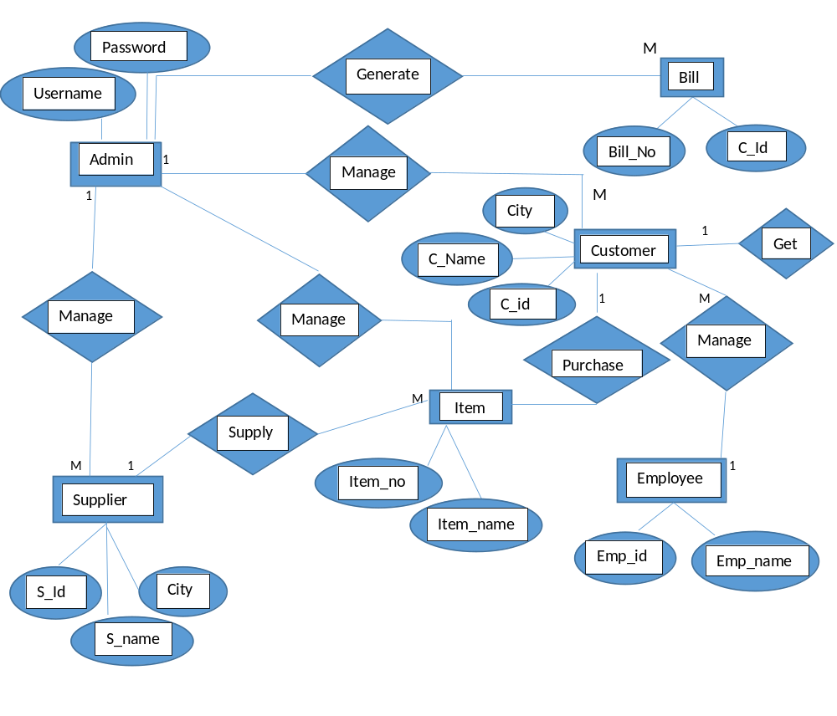

Context Level Diagram

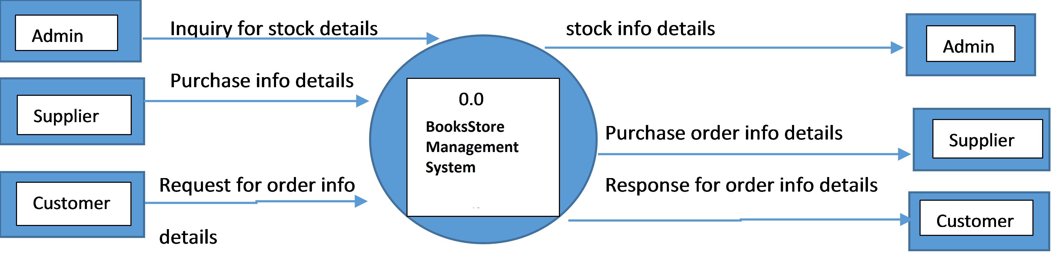

1st Level DFD

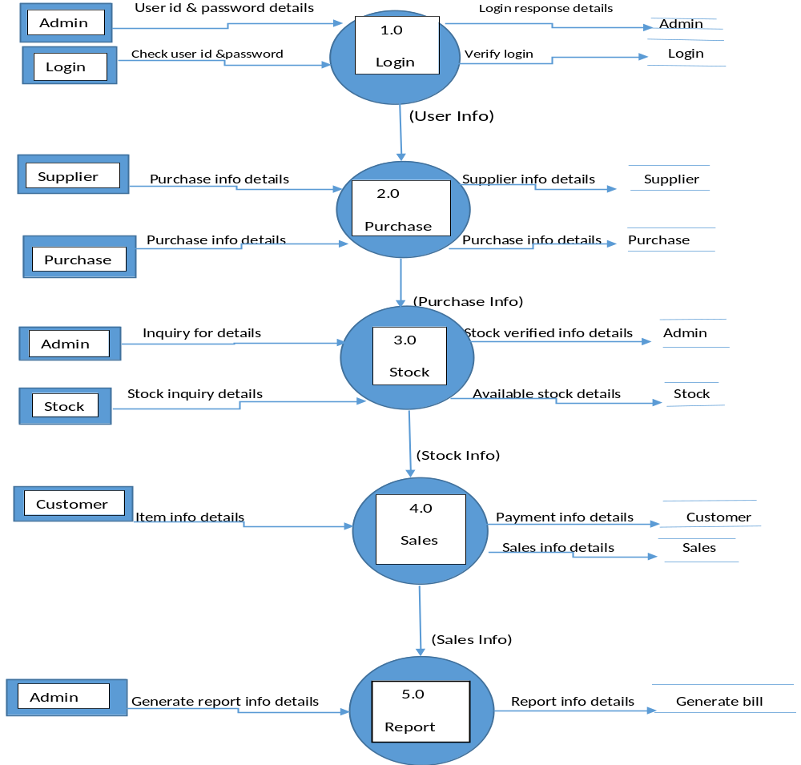

2nd Level DFD(4.0 Sales)

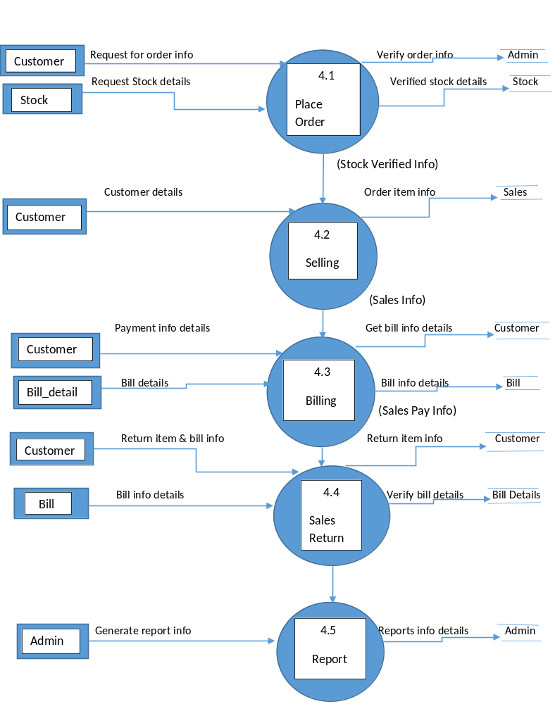

Data Dictionary

Data Dictionary
Data Flow Name | Type | Description
CID | Auto Number | Register Number of Custoemr& Primary key
CName | Text | Customer Name
Address | Text | Customer Address
Email | Text | Register email of customer
Phone | Auto Number | Customer Phone
Gender | Text | Male,female

Login Table
Data Flow Name | Type | Description
User | Text | User Name
Pass | Text | Password

Customer Bill:-
Data Flow Name | Type | Description
Id | Number | Id of bill
Sales _Id | Number | Id of Sales
Sales_Date | Date/Time | Date of sales
Cust_Id | Number | No of customer
Cust_name | Text | Name of customer
Grossamt | Number | Amount of gross
Totalamt | Number | Total amount
Paidamt | Number | Total paid amount
Balance | Number | Remaining balance

Product:-
Data Flow Name | Type | Description
Pid | Text | Product number
bname | Text | Name of book
Publisher | Text | Name of Publisher
isbnno | Text | Isbn no of product
bdesc | Text | Book description
datee | Date/Time | Date
Price | Number | Price of product
Sales | Number | Total sales
quantity | Number | Book quantity
author | Text | Book author name

Purchase detail:-
Data Flow Name | Type | Description
Pur_id | Number | Purchase number
Pur_date | Date/Time | Purchase date
Sup_id | Number | Supplier no
Sup_name | Text | Name of supplier
Pro_id | Number | Product no
bname | Text | book name
isbnno | Text | isbn no
Price | Number | Price of product
Quantity | Number | No of items
Amount | Number | Amount of product

SALES :-
Data Flow Name | Type | Description
Sales_id | Number | Sales no
Sales_date | Date/time | Sales date
Cust_id | Number | Customer no
Cust_name | Text | Name of customer
Pro_id | Number | Product no
bname | Text | Name of book
isbnno | Number | Book isbn
Price | Number | Product price
Quantity | Number | No of items
Amount | Number | Total amount
Supplier bill:-
Data Flow Name | Type | Description
id | Number | Book id
Pur_id | Number | Purchase id
Pur_date | Date/time | Date of purchase
Sup_id | Number | Supplier no
Sup_name | Text | Name of supplier
Totalamt | Number | Total amount
Paidamt | Number | Amount paid
Balance | Number | Remaining balance

Supplier:-
Data Flow Name | Type | Description
Sid | Number | Supplier no
Sname | Text | Name of supplier
Address | Text | Address of supplier
City | Text | City of supplier
Phone | Number | Supplier phone no

Vat:-

Data Flow Name | Type | Description
Id | Number | Id of Gst
Salesid | Number | Sales id
GStdate | Date/time | Date of Gst
Gstpercent | Number | Percentage of Gst
Gstamt | Number | Amount of Gst

Project Screen Shot

LOGIN FORM

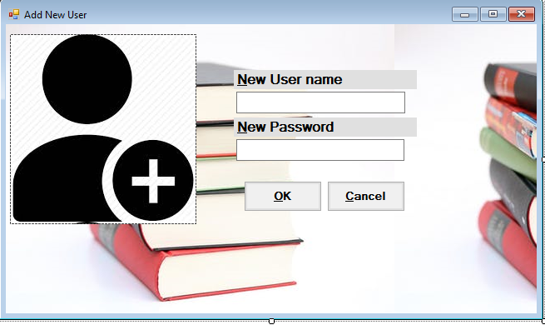

MAIN FORM:-



CUSTOMER INFORMATION:-

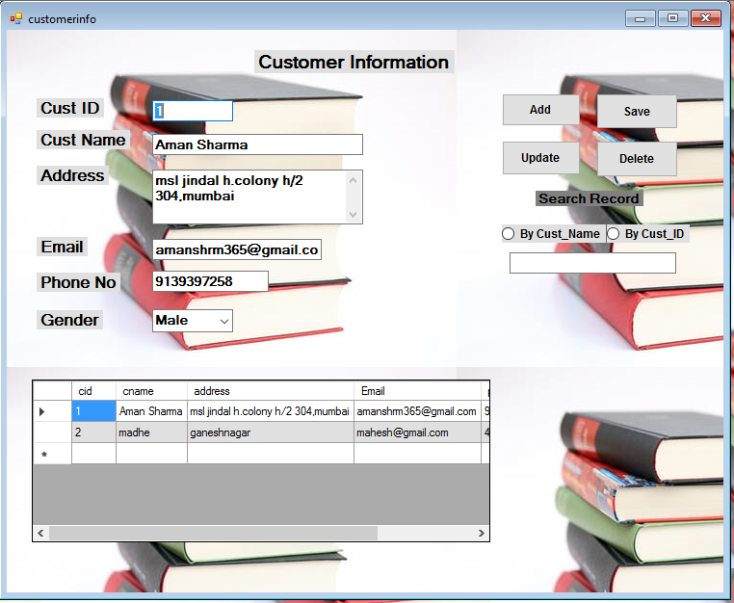
SUPPLIER INFORMATION:-
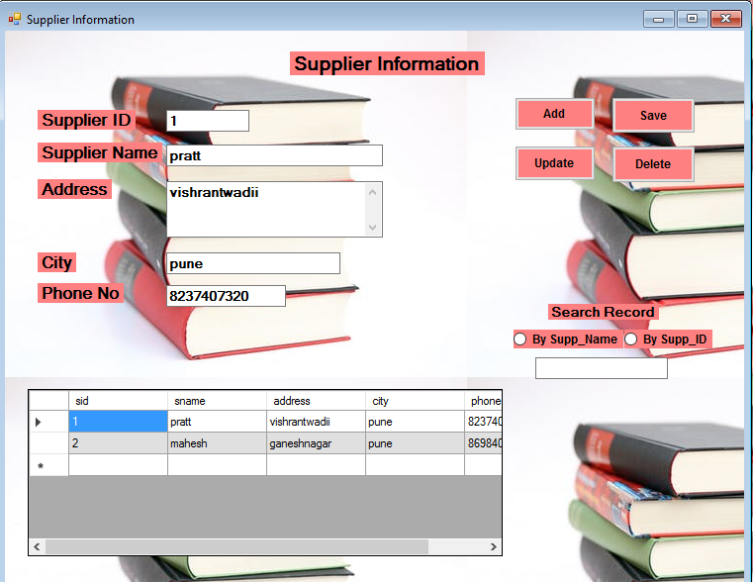PRODUCT INFORMATION:-

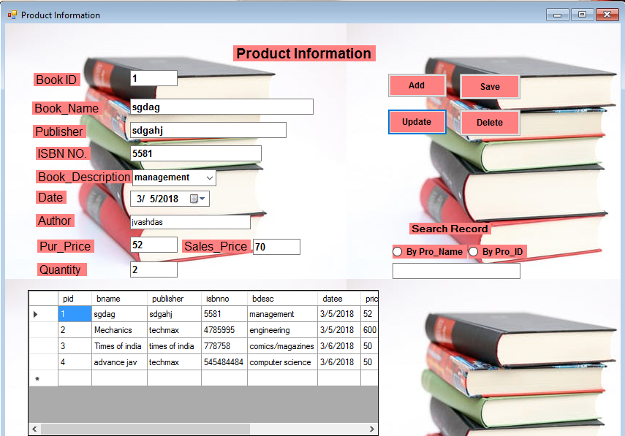
CUSTOMER SALES EDIT:-
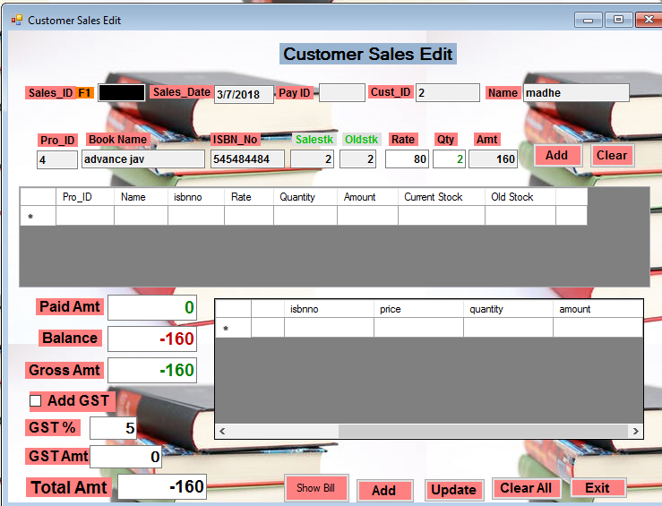
CUSTOMER..SALES:- 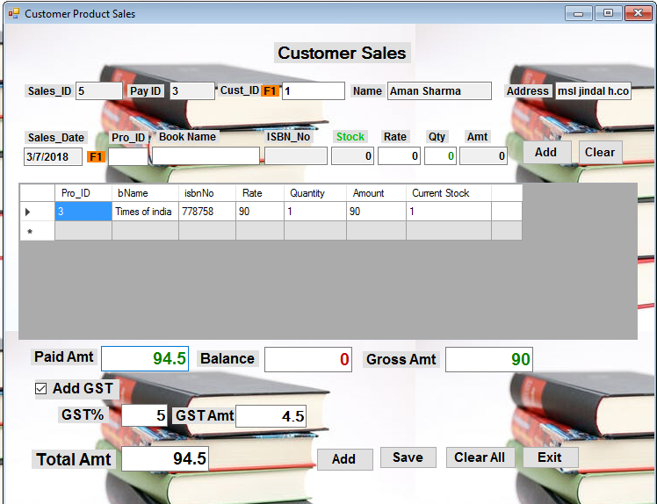
PRODUCT EDIT:-

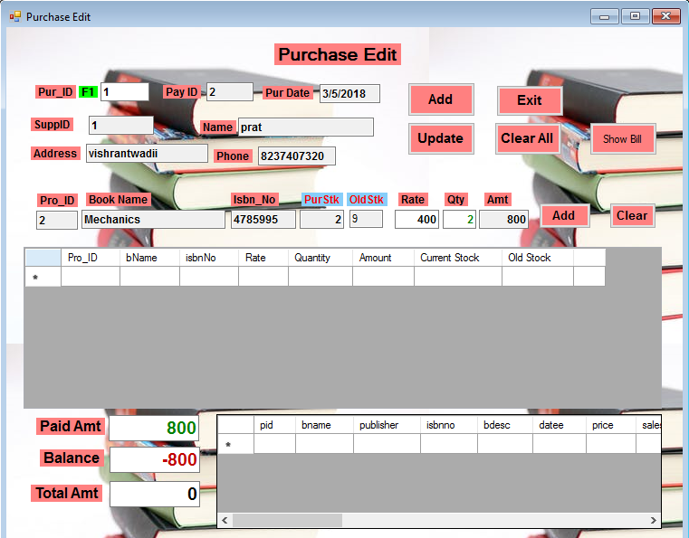STOCK PURCHASE:-
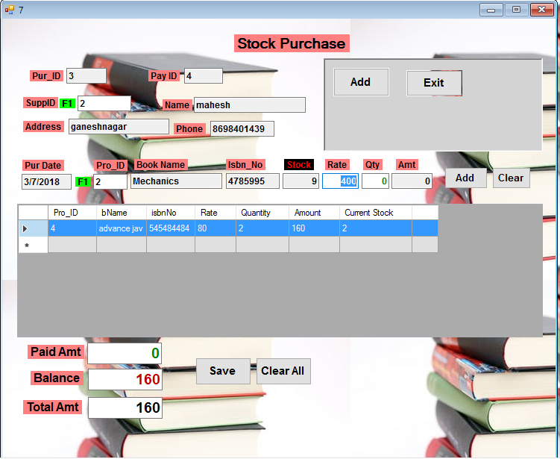
GST INFORMATION:-

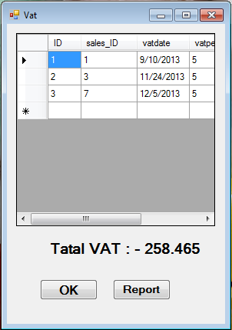

Reports-:

Customer Report

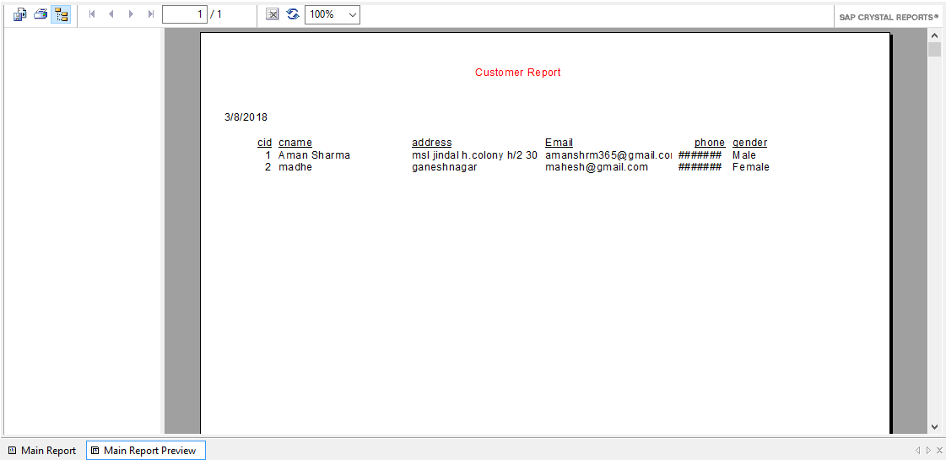

Total Customer Bill Report

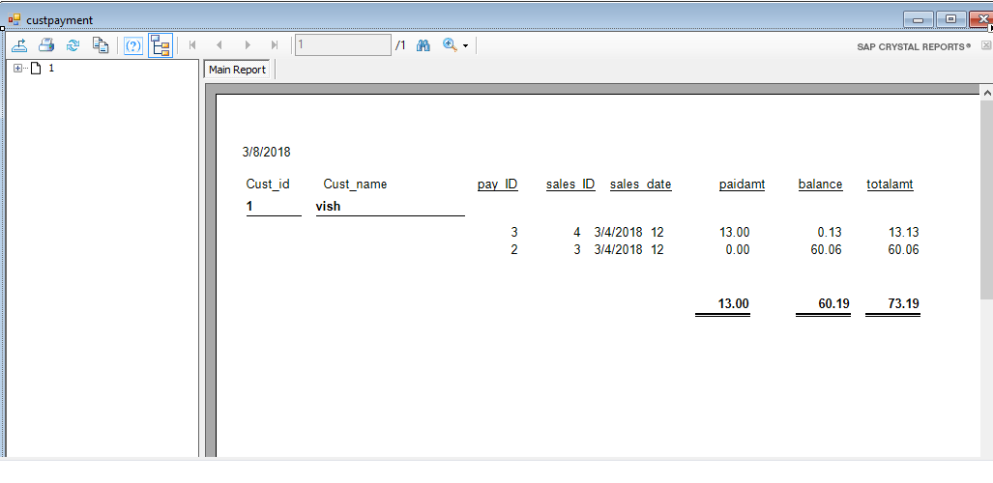
Total customer Product Sales

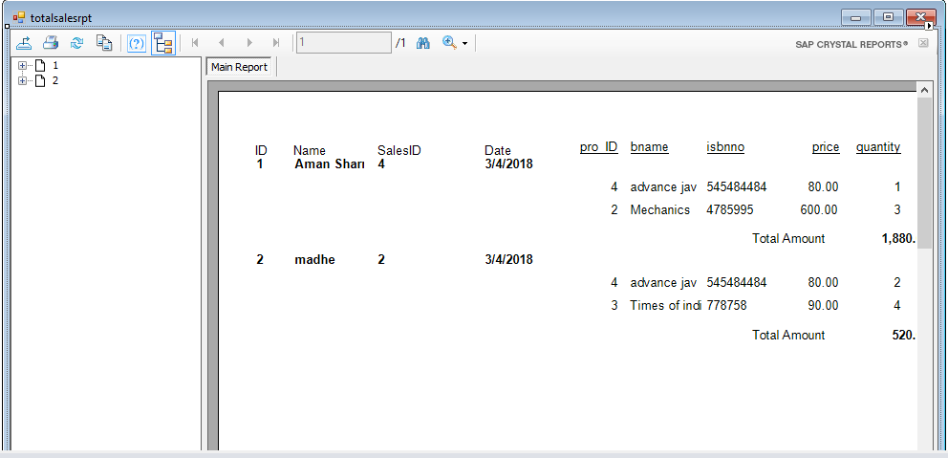

Product Information Report

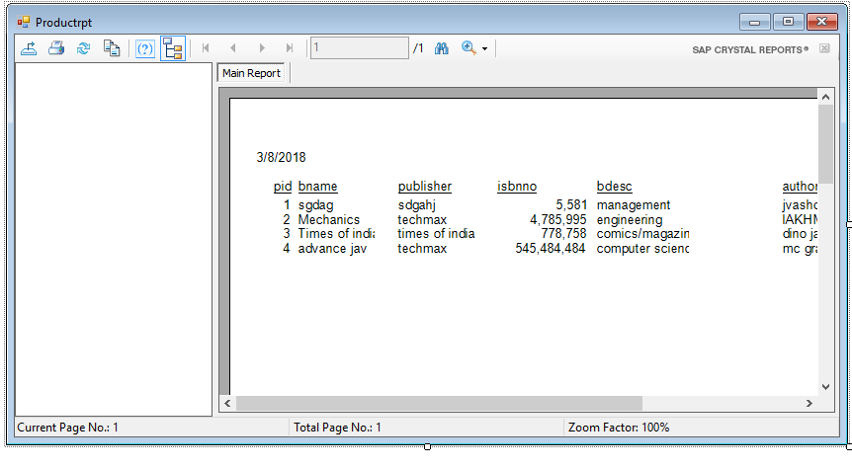

Total Product Purchase Report

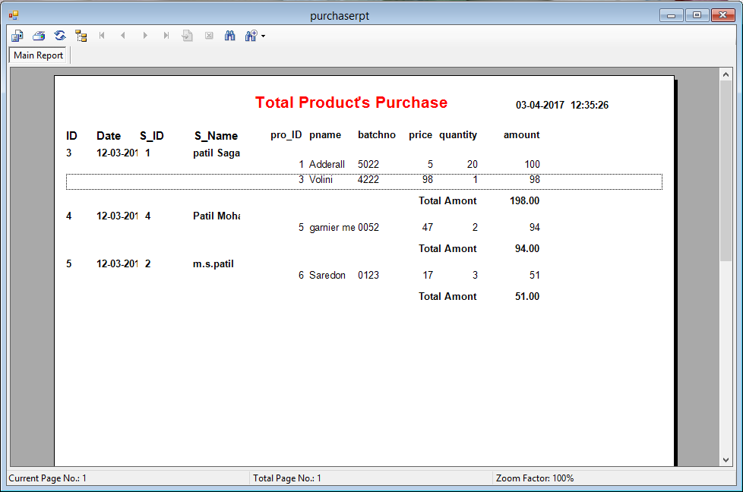

Total Product Sale Report
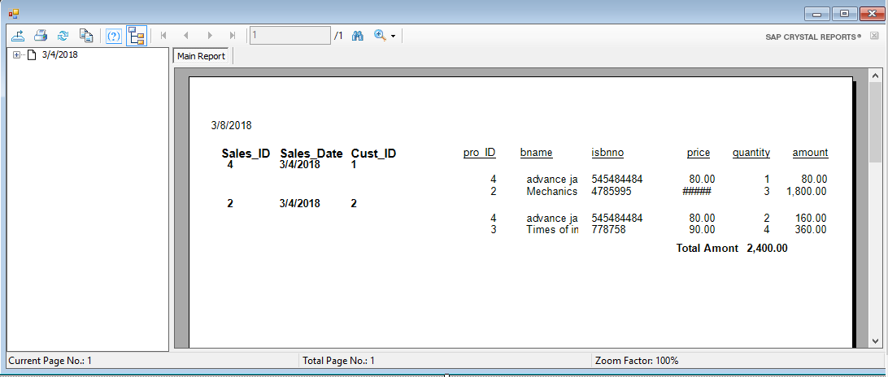

Supplier Information Report

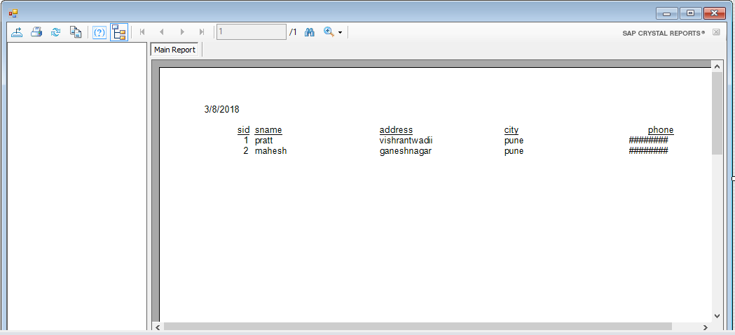

Total Supplier Bill Report

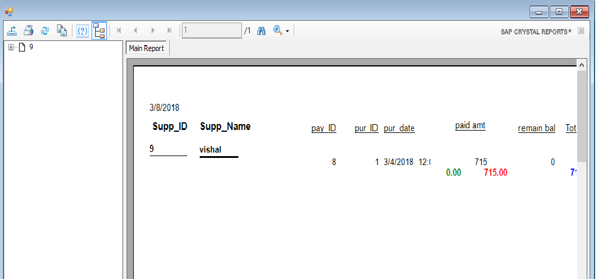

Advantages Of System:

- In this system we provide higher security.
- these system consist of book information also like book publisher , book type, author etc.
- this system is user friendly.
- there is no any Ambiguity.
- Can have personal account.

Disadvantages Of System:

- While Purchasing online there is possibility of account being hacked or when you select online payment there are chances of loss of personal information and account.
- we provide limited facility to use.

Future Enhancement

As any software developed should be always open for changes i.e. any kind of changes made in future should be easily acceptable by the project. Our project “BOOK STORE” intends to provide those features to its users and its further scope of development has been mentioned below.

- To provide a much better and improved interface.
- This project can be enhanced by using Oracle
As a backend in place
- Database can be fully normalized as much as possible.

Bibliography

Website Reference:

https://www.Google.com

www.codeproject.com

Youtube.com

